First Task-Linus Commands

- Git Bash is also a kind of software which will help us to use some basic linux commands if the virtual machines doesn’t work(approx. 20 to30 commands).
- VM ware is Linux based OS and where Git Bash is Windows based OS(operating system).

Used Linux Commands
1. pwd: present working directory.
2. cd: change directory location.
3. ls: List of files available
4. mkdir: create directory
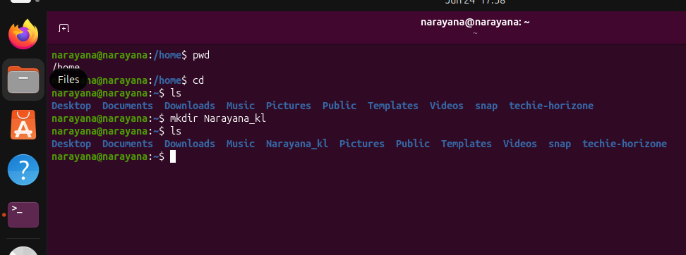

5. mv: editing the directory
6. ls -a: show hidden files
7. ll : list of files and directories are available.
8. touch: create file.
9. rm: delete the file.

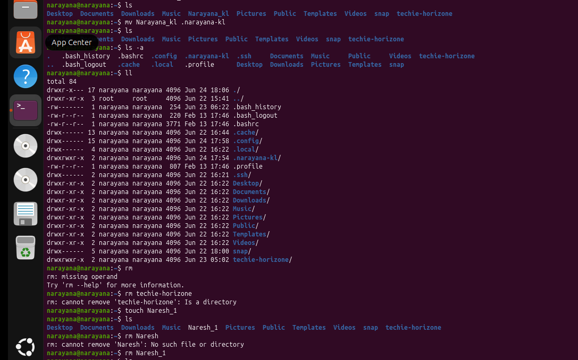

10.rm -rf: delete the directory
11. vi: create file and open editor
12. esc & :wq! : To exist from the editor
13. cat: to read the content in the file
14. date: current date & time
15. wc: read the word count and to know how many lines available
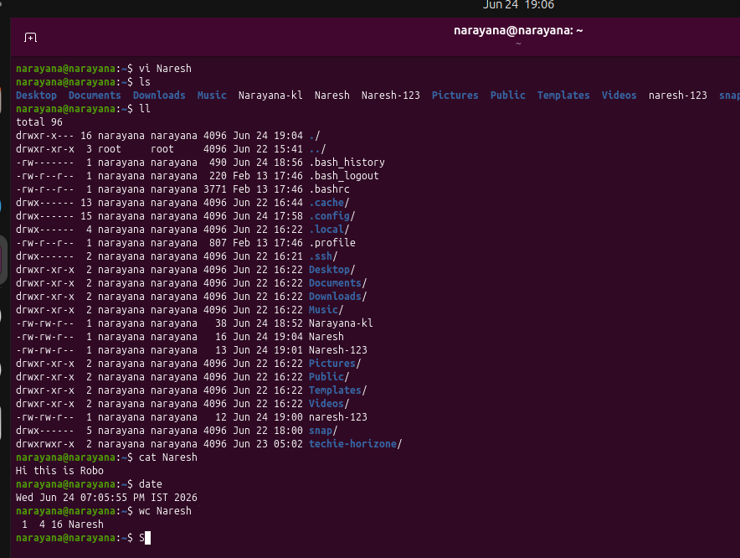

16: history: we can see all the commands which we used

